Tear film telomerase in NEOPHYTE contact lens wearers

DO YOU WANT TO TRY CONTACT LENSES?
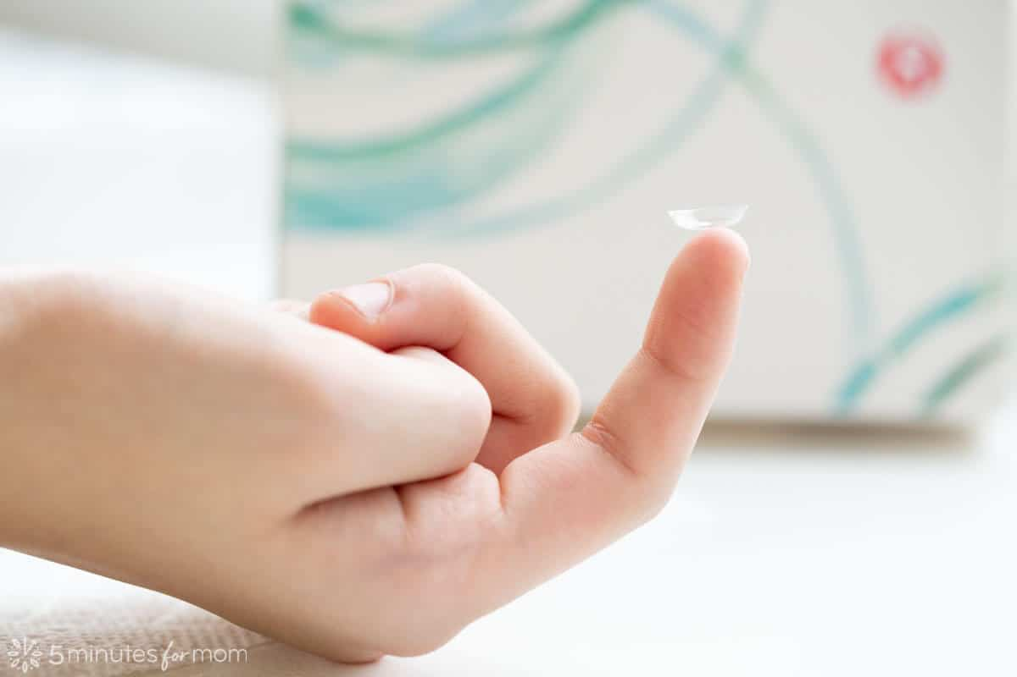
Researchers at UNSW Sydney (The University of New South Wales) are seeking volunteer research participants to learn about the activity and concentrations of telomerase in the human tear film.
Telomerase in human tears

Would the research study be a good fit for me?
The study might be a good fit for you if:
- Are not a contact lens wearer but are willing to try contact lenses.
- Are aged over 18 years.
- Have healthy eyes.

What would happen if I took part in the research study?
The study involves 7 visits including 2 overnight visits. If you decide to take part, we will ask you to attend our clinic on two days at the following times:
Visit | Time | Activities | Duration
V1 | Day 1: Mid-day | Enrolment, baseline data collection, refraction, tears collection, imaging of your corneal nerves. | 50 mins
V2 | Day 1: Before sleep | Tears collection, imaging of your corneal nerves. | 20 mins
V3 | Day 1: On awakening | Tears collection, imaging of your corneal nerves. | 20 mins
V4 | Day 2: Morning | Contact lens fitting | 30 mins
V5 | Day 2: Mid-day | Tears collection, imaging of your corneal nerves. | 40 mins
V6 | Day 2: Before sleep | Tears collection, imaging of your corneal nerves. | 20 mins
V7 | Day 2: On awakening | Tears collection, imaging of your corneal nerves, checkout tests | 30 mins

Will I be paid to take part in the research study?
You will be reimbursed $80 Coles gift card as a compensation for your time and expenses associated with attending the visits of the study.

Who do I contact if I want more information or want to take part in the study?
If you would like more information or are interested in being part of the study, please contact:
Name: Sultan Alotaibi
Email: S.alotaibi@student.unsw.edu.au
Landline: 93859229

